Lab 4: Generalization

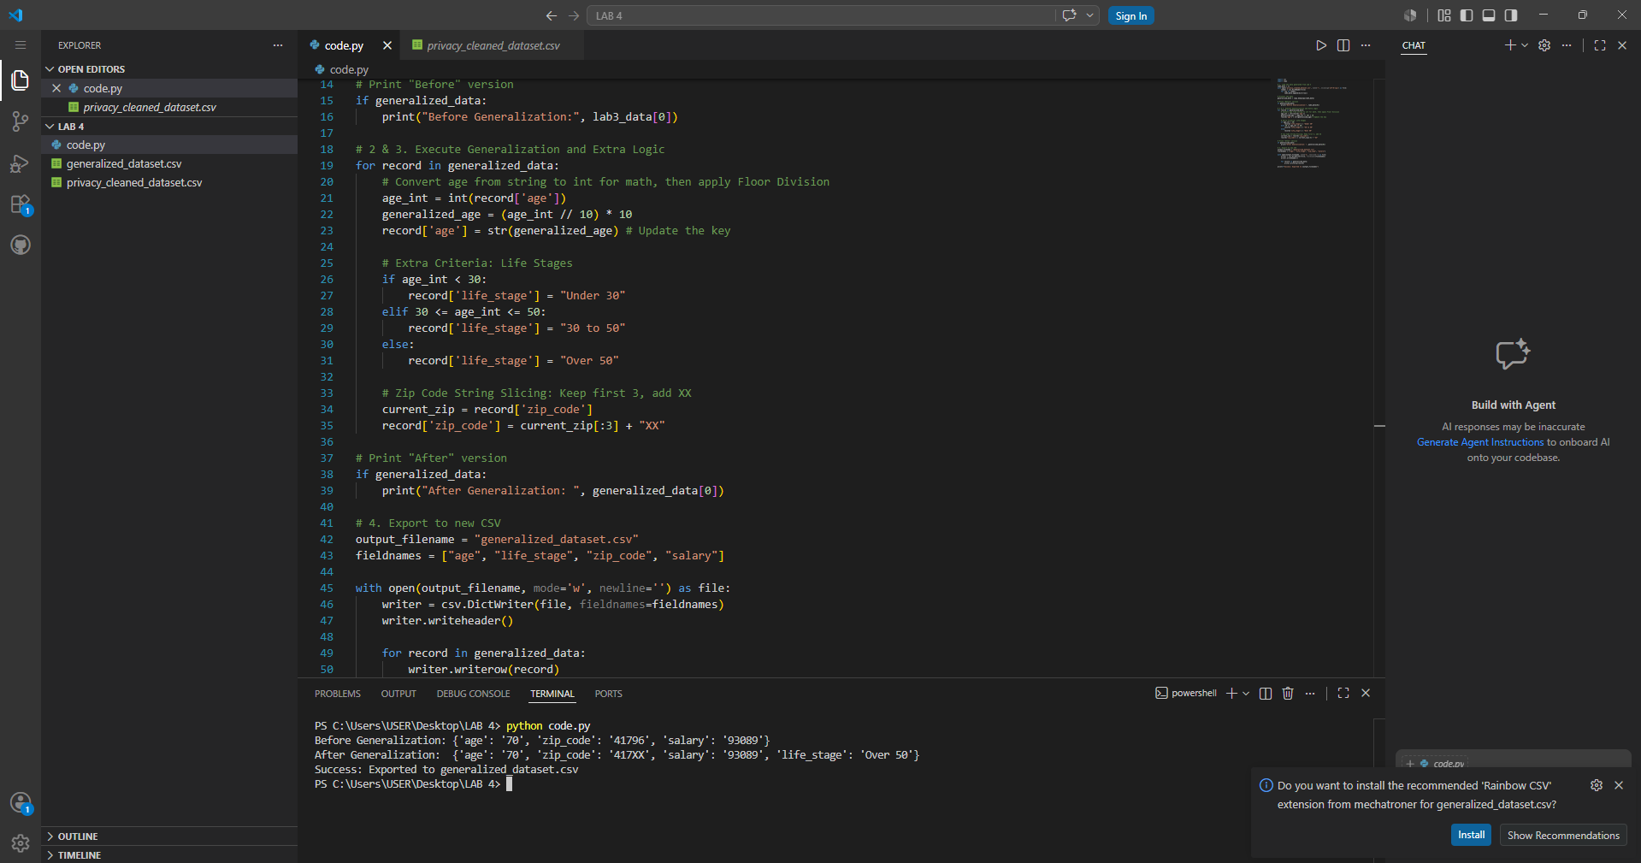
This program demonstrates the generalization technique in data privacy. It reduces the precision of personal information so that individuals are harder to identify while keeping the data useful for analysis. The program processes each employee record by rounding down the age to the nearest decade using floor division. For example, an age of 76 becomes 70. It also categorizes employees into life stages such as "Under 30," "30 to 50," or "Over 50." In addition, the ZIP code is generalized by keeping only the first three digits and replacing the last two digits with "XX", such as changing 41796 to 417XX. After applying these changes, the program displays a before-and-after comparison to show how the data has been generalized. Finally, the modified records are saved into a new file called generalized_dataset.csv. This approach improves privacy because exact ages and ZIP codes are hidden, making it more difficult to identify specific individuals while preserving important information such as salary for statistical analysis.

